### Name : Veeresha M Thotigar Date: 03/25/2019

### Student ID: 16270975

### Email ID: vmt9mm@mail.umkc.edu

### 

## Summary of Project 1:

### **Face Recognition System: Application of Supervised Learning**

### 

#### 

Mode 1: For each subject, use the first five images (1.pgm to 5.pgm) for training the subspace. Use the files 6.pgm to 10.pgm for the performance evaluation.

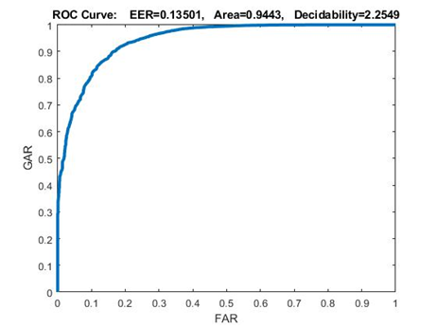

Mode 2: Use the first twenty five subjects (1.pgm to 10.pgm) for training the subspace. Use the rest 15 subjects for the performance evaluation.

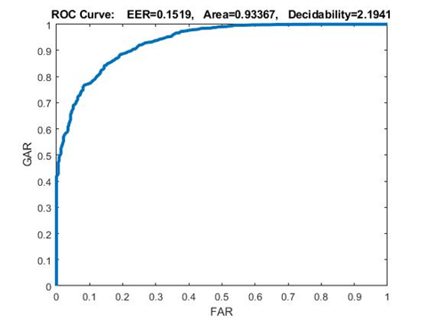

Mode 1 has EER **0.135** when compared to Mode 2 has EER **0.151.**  It clearly shows that mode 2 has more EER than mode 1. For authentication face recognition system requires the genuine acceptance rate to be precise as per results the mode 1 is more suitable, for identification face recognition system requires FAR to be more precise and as per the results Mode 2 performs well and more suitable.